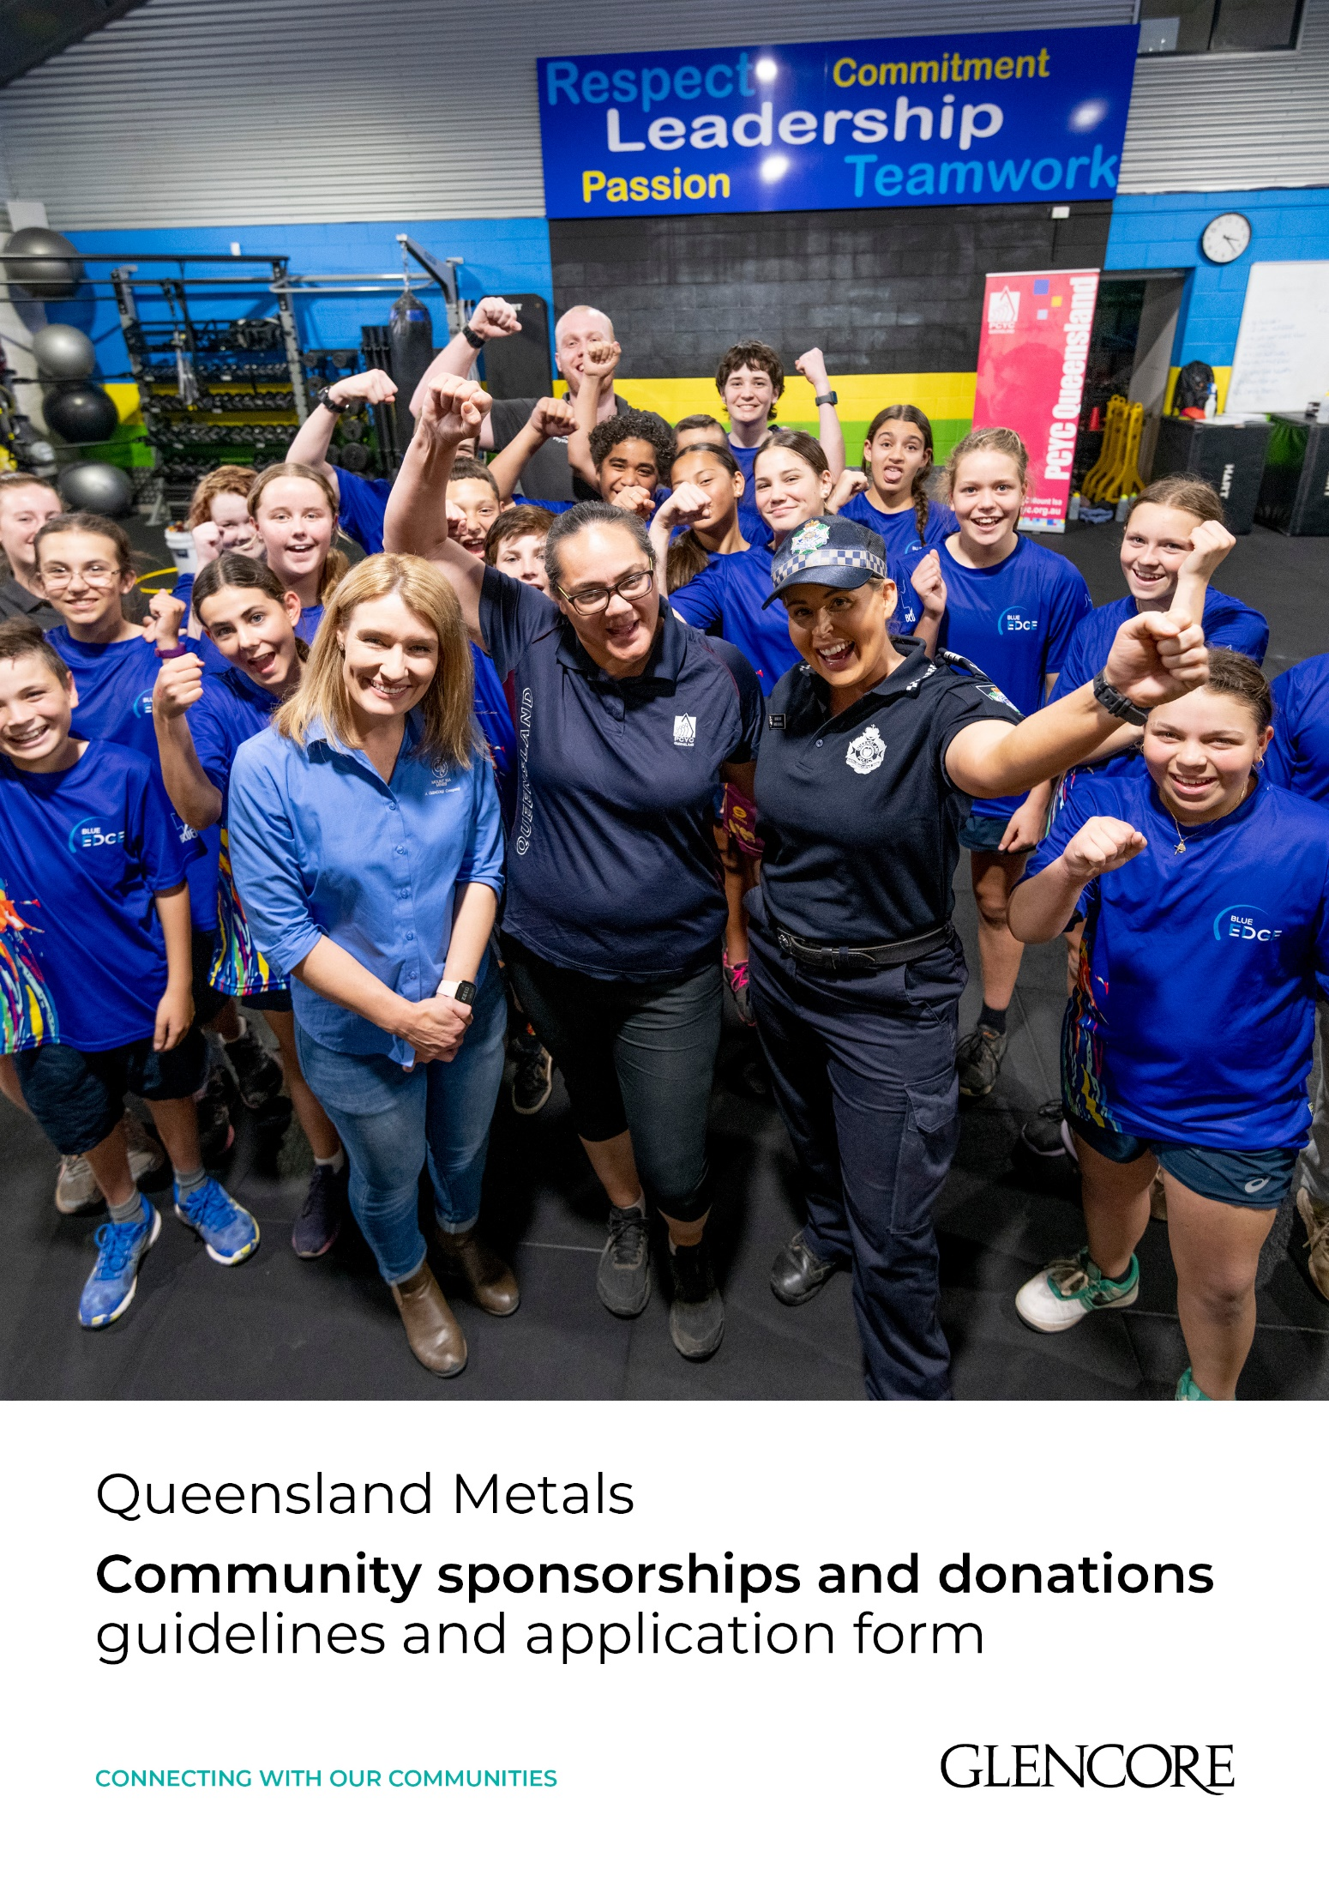

Glencore Community Sponsorships and Donations
Glencore contributes funding for vital Corporate Social Investment initiatives, which is a key part of our commitment to the communities where we operate. We believe that communities should benefit from our operations. This application form is for sponsorships, donations and in-kind support that deliver benefits within the communities of Mount Isa and Townsville.
Key Areas of support | What we do not support  In line with our Corporate Social Investment policy guidelines, Glencore will not support:  - Applications from individuals, from privately owned businesses or for-profit organisations  - Applications seeking support for activities such as academic studies, prize money, uniforms, travel or third party fundraising  - Requests to fund touring sporting teams, or individuals competing in sporting events  - Political parties, political organisations, politicians or candidates for public office  - Church or religious activities which are exclusive to one faith community  - Requests to sponsor events such as conferences or speakers at conferences or symposia  - Organisations producing, distributing or seeking advertising in audio-visual media, including print or electronic media  - Projects that have already been completed | Reporting and evaluation  A formal sponsorship agreement is entered into which requires specific Key Performance Indicators (KPIs) and sponsor benefits in agreement with Glencore. An acquittal report template will be provided, in which the sponsored entity must detail the outcomes achieved through the sponsorship.
  - Education and skills
  - Enterprise development / economic diversification
  - Environment
  - Community health and well being
  - Infrastructure
  - Humanitarian and emergency response
  - Strengthening local institutions

Eligibility
To receive funding applicants must:
- Be incorporated
- Provide services or manage sustainable community initiatives that contribute to the well-being and development of the local communities of Mount Isa and Townsville
- Be a community organisation, not-for-profit group or government agency
- Address the criteria listed in the application form
Application process
Our Corporate Social Investment program calls for applications on a quarterly basis. Four rounds of funding are distributed in January, April, July and October each year.

Quarter | Applications open | Applications close | Notifications | Payments
1 | 9 November | 20 November | 20 December | January-March
2 | 8 February | 19 February | 20 March | April-June
3 | 10 May | 21 May | 20 June | July-September
4 | 9 August | 20 August | 20 Sept | Oct-December

How to apply

For more information contact:

Glencore Mount Isa Mines
Jemma Schweikert
Community Relations Advisor
Email: jemma.schweikert@glencore.com.au

Glencore Townsville Operations
Roslyn Brice-Houseman
Community Relations Advisor
Email: roslyn.brice-houseman@glencore.com.au

Glencore application form
This application form is for our two Corporate Social Investment programs. Our Community Assistance Program which provides sponsorships, donations and in-kind support for local events and initiatives and our Futures Fund Program for large infrastructure projects that deliver benefits within the communities of Mount Isa and Townsville.
To help us determine which program you application will fall under please answer the following:
Less than $14,000 ($10,000 USD)
For $14,000 and above ($10,000 USD)
A large infrastructure project?

Date of application
Glencore site |  | Choose an item.
Organisation name applying
Amount requested (GST excluded)
Brief project description / title

Application details
Organisation Name
ABN
Address
Key Contact
Position
Phone
Mobile
Email
Organisation Structure |  |  | Choose an item.
GST Registered |  |  | Choose an item.
Please detail the types of services your organisation provides and how your organisation became involved in such operations?
Has your organisation received funding from Glencore in the past three years?  If yes, provide details on previous sponsored projects, and whether your organisation delivered against all targets in a timely manner as per your Sponsorship Agreement. |  |  | Choose an item.

Project details
Sponsorship category | Choose an item.
Project description
What does the project involve? If there are multiple components, explain these. If this application relates to part of a larger project, explain relevant connections and background. What has motivated this project?
Project timeframe (start and finish dates)
Objectives

What are the project’s three main aims or objectives?
How will your project benefit the local community?
Approximately how many people in your community will benefit? (please provide figure)
Is your project sustainable (will not need more funding) for three years or more?

Sponsorship benefits
Please detail the recognition and benefits your organisation would provide to Glencore to acknowledge sponsorship of this project.
- Some benefit categories are provided as suggestions however, these are not all expected to be provided – please amend according to the scale of your project and the capacity of your organisation to provide these benefits
- Add / delete rows to the table as required
If successful in your application, these benefits may be incorporated into your Sponsorship Agreement as commitments for you to report against in your End of Sponsorship Report.
Category | Benefit | Due Date
Social Media
Local Media
Website
Newsletter
Official Events
Signage / branding
Advertising
Public Address System / big screen
Merchandise / give-aways
Photographs
Other

Project budget template
All Sections must be completed
Total amount of funding required for your project to proceed? (GST excluded)
How much funding is being sought from Glencore? (GST excluded) |  | Please detail how you intend to spend the requested Glencore funds:
 |  | Item |  | Amount $ (GST excluded)
 |  | TOTAL
Please detail any in-kind support requested from Glencore
What contribution will your organisation make towards the project (funds and / or in-kind)?
Please provide the funding recipients name and address | Name | Address
Please provide the name, address and currency of your organisation’s primary bank and any bank that will be used for the engagement with Glencore | Name | Address | Currency

OTHER CONTRIBUTORS
(Complete this section if relevant to your project)
List the names of any other sources of funding / support you are seeking for your project | Amount requested (GST excluded) | What would the requested funding be used for? | Indicate if the funding is confirmed / the date you expect to receive confirmation | Does your project delivery / application rely on this funding being received?

By signing the below I confirm on behalf of my organisation that:
- I am duly authorised to complete this questionnaire and to disclose to Glencore and its affiliates any information contained herein or contained in any document enclosed hereto, including but not limited to any personal data
- I confirm that this disclosure does not breach any applicable laws and regulations, including but not limited to applicable data protection laws or state secrecy laws and I consent to Glencore storing the provided information in accordance with applicable laws
- The answers provided in this questionnaire are accurate and complete to the best of my knowledge and that I have performed such inquiries as necessary to verify the answers
- We understand that false statements, incomplete, incorrect or misleading information may result in termination of the business relationship with Glencore
- Glencore is permitted to provide information provided in this questionnaire as well as the documentation provided in addition to third parties for background screening purposes
- We: (i) have read; and (ii) agree to abide by Glencore’s Code of Conduct, Supplier Standards and Anti-Corruption Policy in providing services under the proposed engagement (https://www.glencore.com/who-we-are/governance
- We will provide a periodic Activity Report when requested by Glencore for the duration of the proposed engagement

For information on Glencore’s collection and processing of personal data, please refer to the privacy notice at https://www.glencore.com.au/privacy-policy

If, in the performance of this engagement, you become aware of any potential breaches of Glencore’s policies or procedures, you may use the ‘Raising Concerns’ form on the Glencore website at https://www.glencore.com/sustainability/ethics-and-compliance/speaking-openly#misconduct

__________________________________
Signature of Authorised Officer

__________________________________
Name of Authorised Officer

__________________________________
Office Held

Date: _____________________________

Submission of Application
This application should be submitted to the following contacts:

Glencore Mount Isa Mines
Jemma Schweikert
Community Relations Advisor
Email: jemma.schweikert@glencore.com.au

Glencore Townsville Operations
Roslyn Brice-Houseman
Community Relations Advisor
Email: roslyn.brice-houseman@glencore.com.au

